Accessing Course Reserve Reading Lists in Leganto

- Enter Blackboard at learn.wsu.edu and click on the link for your course.
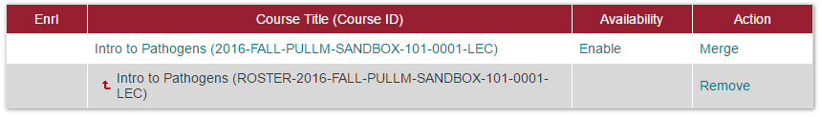

- From the left panel, open the Leganto area, and click on the link named “Leganto Course Reserves (Access eReserves Here).”
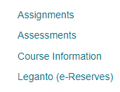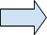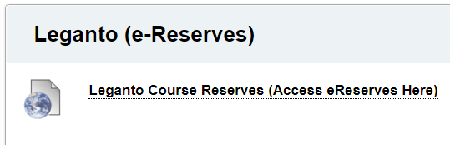
(Note: Your instructor might have given these links slightly different names. Please ask your instructor if you are not seeing this same wording.)

- You should now be at the reading list for your course.
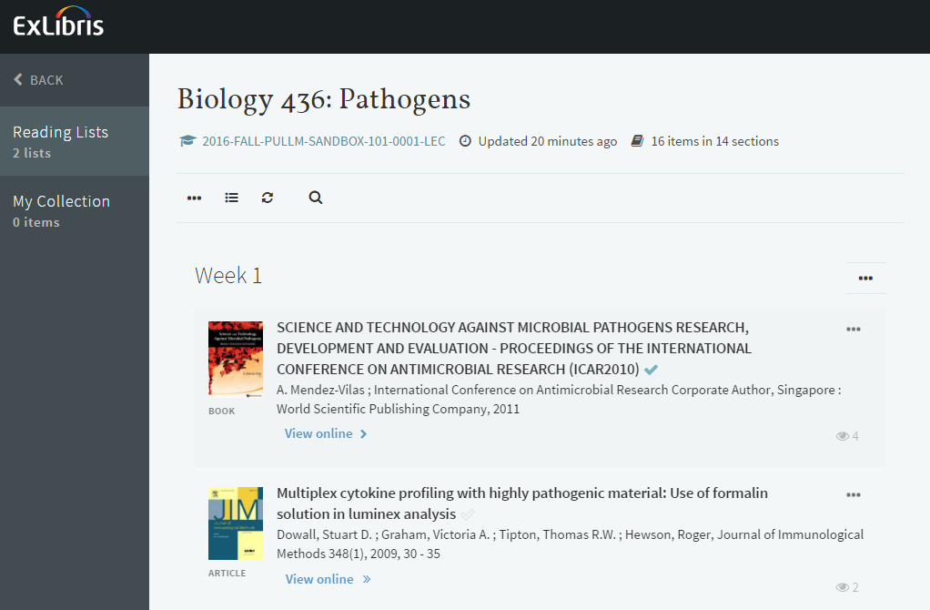

- A short video showing the same: http://www.screencast.com/t/dto7D7OY.
Navigating Icons in Leganto

Viewing options

- Find Physical Book in library by going to Available At information
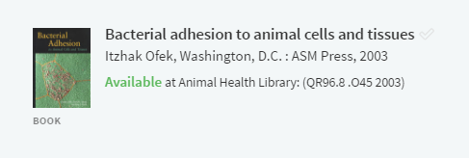

- Click View Online to read online materials (for WSU e-materials)
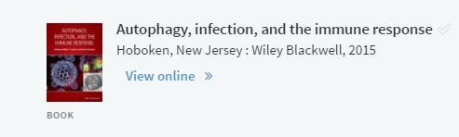

- Use the Download link to access PDF (for digitized WSU items)
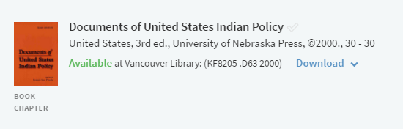

- Use the View using SIPX link to access PDF (for items we do not own)
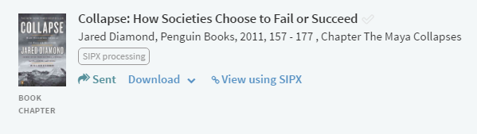

- Download or View in Browser
- NOTE: the price should always be $0.00 for WSU students
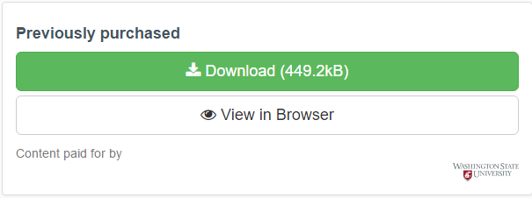

Reading list options

- Export all reading list items to Word or as PDF
- Toggle the view to un/hide items in your sections
- Refresh the page
- Search for an item on the page

Section options
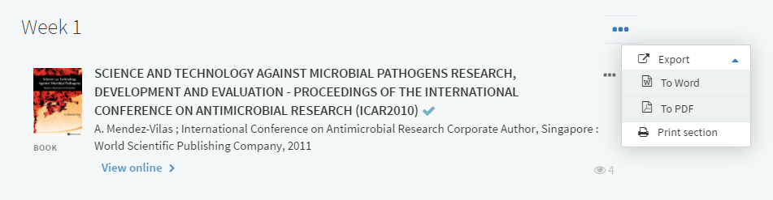

- Export items from current section to Word or as PDF

Item options
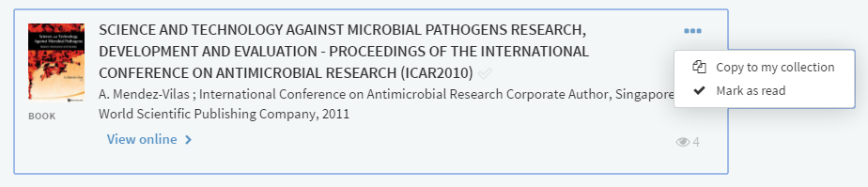

- Copy item to your personal collection of items
- Mark item as read (you can also mark as unread if you made a mistake)

